
Austrian Audio Extends Warranty for Studio-Grade Line of Professional Headphones
Customers can now benefit from up to five years of warranty coverage on the company’s finest hand-crafted headphones.
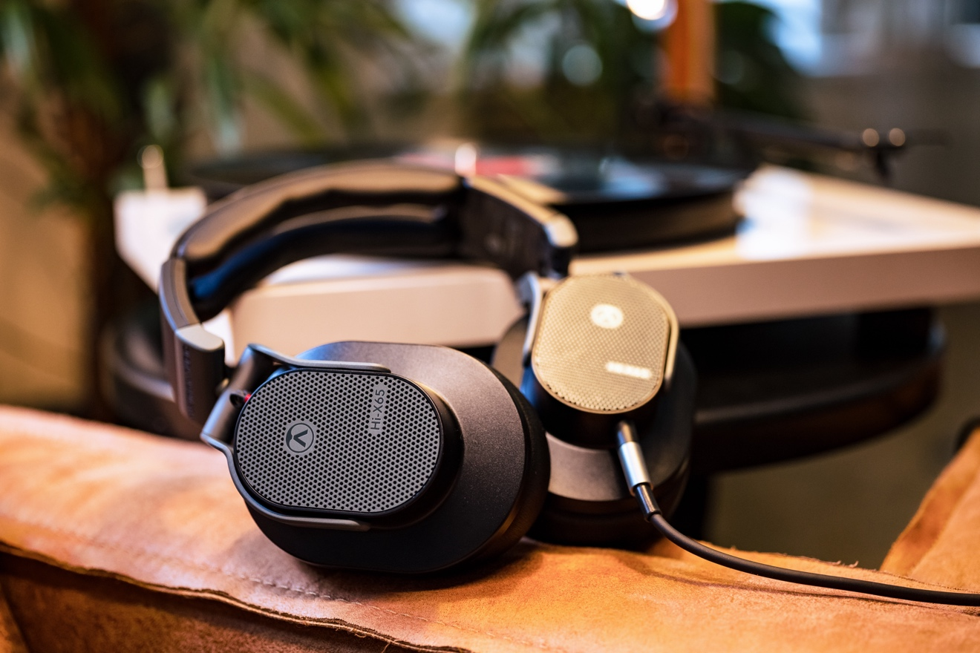
Vienna, Austria, March 19, 2024 — Austrian Audio announced that each product in its line of high-precision made-in-Austria headphones will now include up to five years of comprehensive warranty coverage.

Effective immediately, purchasers of the pro audio company’s The Composer, Hi-X65, Hi-X60, Hi-X55, or Hi-X50 headphones can register their products on Austrian Audio’s website for the five-year warranty, and retaining proof of purchase will ensure they are covered.
Designed, engineered, and built in Austria, this line of pro audio headphones from the Vienna-based company delivers immersive sound quality ideal for any professional musician, producer, engineer, or discerning audiophile.
“We believe in the quality and durability of our products,” noted Martin Seidl, Austrian Audio’s CEO. “Extending the warranty to five years reflects our confidence in the tools we make and our commitment to the artists we design them for. It’s our responsibility to provide top-tier service for these top-tier products.”
New extended warranty coverage details
With a quick visit to this registration page on the company’s website, the end user can now register to extend to a total of five years (60 months) from the date of purchase.
The coverage applies to the following Austrian-made headphone models.
- The Composer: Designed for the ultimate immersive listening experience.
- Hi-X65: Open back design, created with mixing and mastering in mind.
- Hi-X60: Best reference closed-back headphone — wherever isolation is needed.
- Hi-X55: Perfect for critical detailed audio work, such as audio editing and restoration.
- Hi-X50: Ideal for live music monitoring, DJ use, and contemporary music production.
To learn more about these products and see detailed information on Austrian Audio’s updated warranty coverage, visit the company’s website here.

About Austrian Audio
Austrian Audio opened its doors in 2017 following the closure of the AKG offices in Vienna and set out to create something new, challenging, and respectful to its heritage. The new company started with a core team of previous AKG personnel from management, acoustics, electronics, test and measurement, mechanical design, RF/wireless, and software/firmware, bringing 350 years of cumulative engineering experience to the new company.
For more information, visit austrian.audio.

